

Rates 2026
Auto / Typ NEW Cars | Photo | Days | April – 31.05 & 01.10 -31.10 | 01.06 – 30.06 | 01.07 – 30.09
A Group  (z.b. Fiat Panda) | 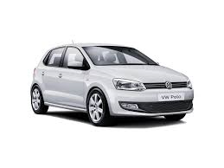  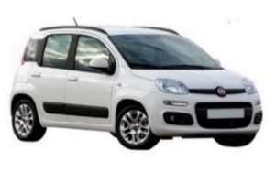 | 1 DAY | 40 | 45 | 50
A Group  (z.b. Fiat Panda) |  | 3 DAYS | 100 | 120 | 140
A Group  (z.b. Fiat Panda) |  | 5 DAYS | 160 | 190 | 220
A Group  (z.b. Fiat Panda) |  | 7 DAYS | 240 | 260 | 300
B Group  (z.b. VW Polo) |  | 1 DAY | 50 | 60 | 65
B Group  (z.b. VW Polo) |  | 3 DAYS | 130 | 140 | 175
B Group  (z.b. VW Polo) |  | 5 DAYS | 200 | 230 | 270
B Group  (z.b. VW Polo) |  | 7 DAYS | 260 | 280 | 350
C Group  (z.b Peugeot 301) | 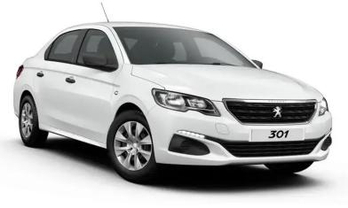 | 1 DAY | 60 | 65 | 65
C Group  (z.b Peugeot 301) |  | 3 DAYS | 170 | 200 | 220
C Group  (z.b Peugeot 301) |  | 5 DAYS | 270 | 300 | 350
C Group  (z.b Peugeot 301) |  | 7 DAYS | 350 | 380 | 450
Mini Van  Fiat Talento 9 seats | 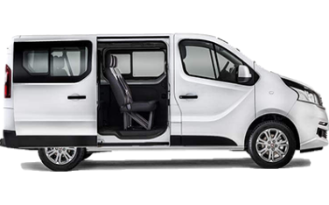 | 1 DAY | 90 | 100 | 110
Mini Van  Fiat Talento 9 seats |  | 3 DAYS | 240 | 270 | 300
Mini Van  Fiat Talento 9 seats |  | 5 DAYS | 380 | 420 | 450
Mini Van  Fiat Talento 9 seats |  | 7 DAYS | 500 | 550 | 600
Stay & drive (Rent a Car, Motorbike,Bicycles)
We arrange your stay in combination with a rented car or motorbikes same or less days, including full insurance and free kilometres.
Stay & Excursion
We arrange your stay in combination with different excursions.There is a wide range of fantastic excursions to discover the island of Crete
